

**Family Feedback**

**Needs Assessment**

**April 26, 2021**

Families were invited to participate through an announcement in the “Parenting Virtual Students” newsletter, in an invitation sent through the system’s messaging system, and school level invitations. Over 60 families volunteered to participate in the free on-line event. The volunteers received a confirmation email confirming they were signed up and an email providing a link prior to the event. The families also received a digital copy of the survey that would be presented at the live virtual event. Seven families attended the virtual event and twenty-four completed and turned in the survey online.

The groups were organized into Elementary (Pre-Kindergarten to 5th grade) and Secondary (6th to 12th grad). During the live event, a presentation was facilitated by three of the Special Education Parent Advisory Council Members (SPED PAC) while the Ombudsman and Parent Liaison provided technical assistance and clarifications as needed. The format of the survey is similar to the State’s Parent Survey only additional questions were added addressing Culture Sensitivity and Virtual Learning. The collected information was shared primarily through pie charts, however there were some situations that the information did not lend itself to charts (Answers were not related) so the information was listed in bullet form.

Some interesting comments include: Parents of elementary students reported positive reactions to the schools that provided specialized materials, learning packets, and other materials in filing cabinets in front of the school. (Accessible after school hours) Parents from all ages reported frustration both in turning in assignments virtually (Reported not getting confirmation of turning them in and difficulty in turning in late work) and the lack of consistency in forms of communication, even in the same school (Some teachers email while others use canvas or Aspen.) Finally, although most responded positively to questions about cultural sensitivity, it was indicated there was a lack of events or supports at the school. (Most reported that the schools did not have any events or supports)

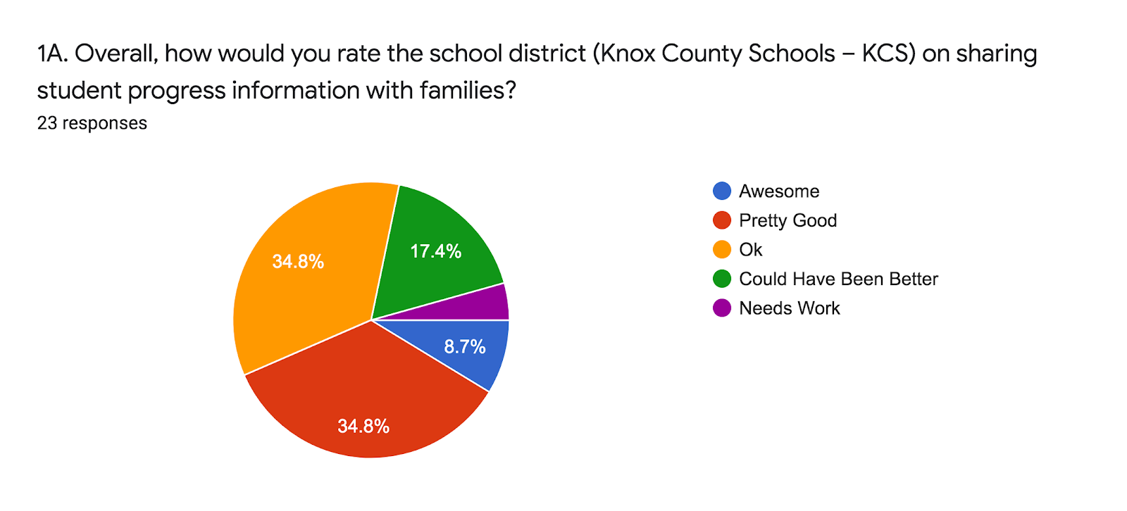

**What Improvements would you suggest?**

**Communication-**

* More Frequent reports (not just IEP Goals)/ more info about grades
* Enter grades in timely matter/ too much flexibility for teachers
* Emails from staff/ more bench mark communication/ RTI explanations
* Middle school parent/ teacher communication
* Share information with BOTH parents
* Parent friendly notification
* Parent asking for visuals progress (such as videos)

**Resources:**

* More resource aid in task completion
* More Therapy offerings (OT, PT and Speech)
* Information sharing specifically for special needs (Not just blanket general education information
* Aspen not user friendly
* Too much variation in communication (Some use Aspen, others Canvas, email etc. Families do not know how to access information for everyone even in the same school
* Use of filing cabinets very useful (parent’s get specialized supplies and can pick up on their schedule
* Teachers (even in the same school) use various modes of communication (Canvas, email, Aspen) Parent’s need more universal platform for communication
* Encourage continued use of filing cabinets in front of the school

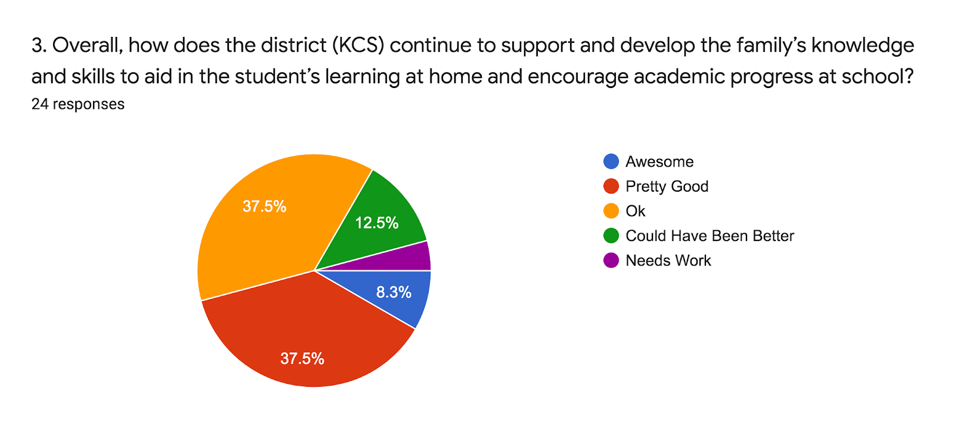

* Teachers try to support but we have had much difficulty at home learning behaviors caused from stress and anxiety – we don’t do well virtually. . . navigating online was a struggle to support a child
* I feel like the elementary school teachers were better with communication. I also understand the student load is a lot more in middle school.
* Resources in the filing cabinets outside of the school are very helpful. Full of resources (such as specialized writing paper and hands on activities) Allow for parent to pick up on their schedule.
* Make adjustments to expectations
* We use this information to collaborate with our child’s ABA therapist for treatment

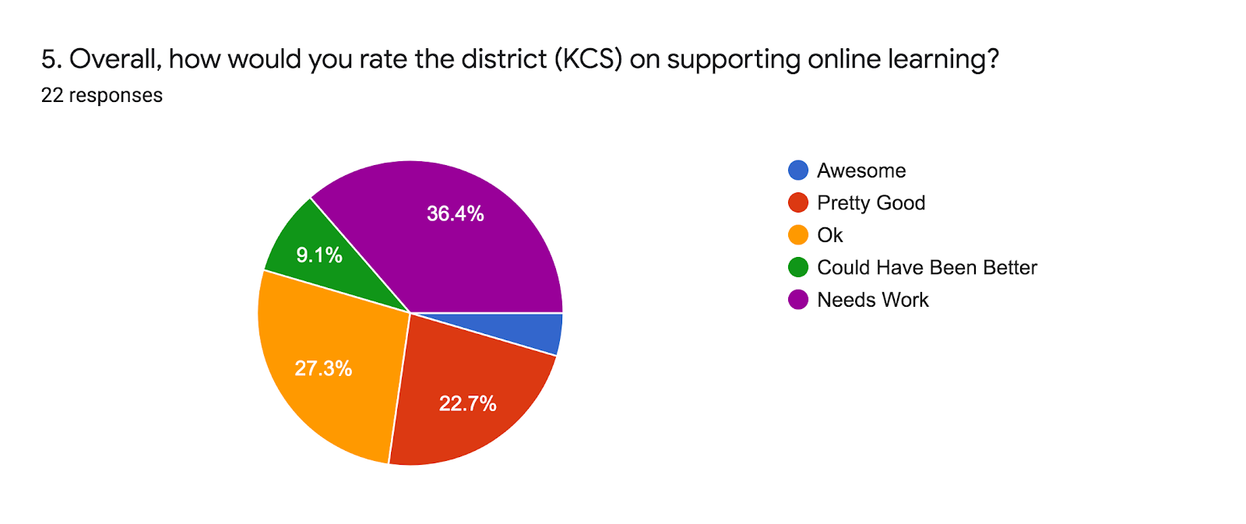

* Having subjects organized so that completing the task would be easier, and also a confirmation knowing you've submitted the subject.
* Transparent communication and follow-up along with teachers letting you know what students should be working on or if class is not in session.
* Maybe a mandatory "expectations session" where parent and student are required to attend virtually so everyone knows the deal.
* Virtual learning is extremely difficult for the children in my son's room. His teacher and support staff do an amazing job with the resources they have. However, it is very difficult to keep the attention and encourage participation virtually.

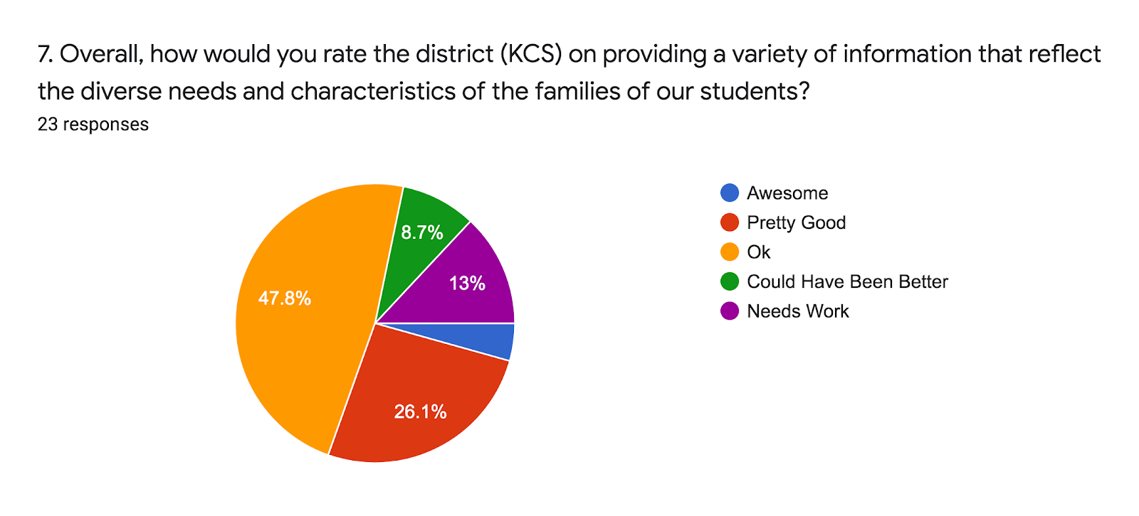

* I believe both of my children’s elementary and middle celebrated diversity well
* Not anything or special needs students
* Non provided and my son is a minority
* This school year, not much. Previous school year culture night

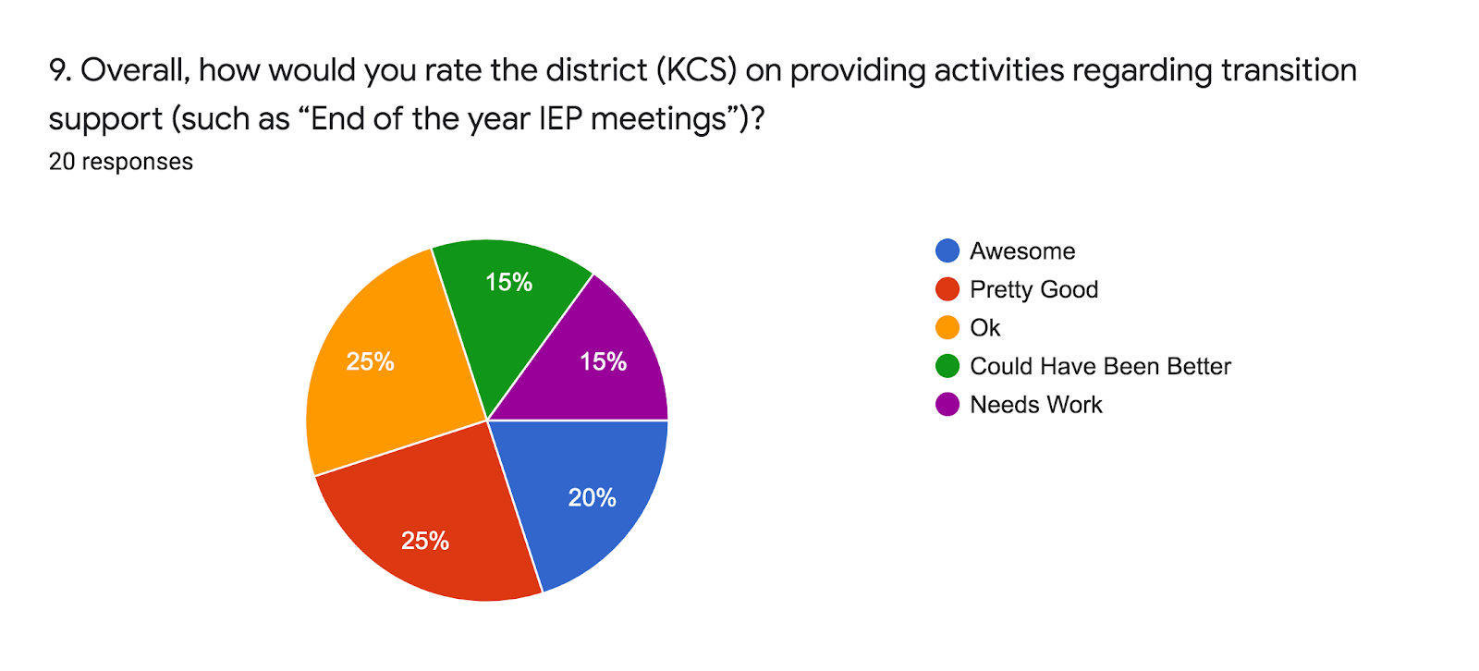

* It was awesome when the school gave all the students the opportunity to visit the middle school, while my son was still in 5th grade
* Nothing but right before the end of the year, I was advised we had an option to transfer to NMS for the Autism program, but because it was so late - we had to wait until the beginning of the next school year to actually transfer. Poor planning.
* Elementary did well. Middle school has been disappointing
* Coming from Johnson City, first school year at Knox County, it was very basic and generic, IEP did not cover the importance of ID, just her physical impairments. Waste of time
* My son will start high school in August 2021, they did a virtual meeting to help my son transition to high school.
* Much less transition support maybe because of Covid
* None- Again I had to ask for an IEP meeting to get her schedule done
* The Transition conference is very helpful. I intend to continue to participate until my daughter graduates (Planning after High School)

**What additional supports are needed to support future success?**

* Extended school year.
* Knox county school has always provided my child with the best learning and teachers on this planet.
* I would like to see after school and summer activities offered more in their school they attend. There are limited locations that offer these options to date. I know with my son, by the time he adjusts to a new location and a new staff then the activities have concluded. I know it is an extra burden on an already taxed staff but the offer could be made. I know some of the special needs staff already participate in these activities with my son's peers. It seems their expertise could be better utilized while still giving them an option of supplementing their woefully low income.
* I'm not sure- but possibly trade school for some of our SPED students
* I believe that students should be encouraged to follow subjects that they excel in.
* If a student is in 10th grade on a 7th-8th grade level, don’t move the child on to the next grade without speaking about summer school, tutoring, or something to help the child improve and excel. Passing a child onto the next grade doesn’t help them succeed, it hinders them because they aren’t learning what they’ll need in society
* Pre-K students get to attend school 5 days a week to get practice for school readiness. More time spent in speech and OT therapy. One on one aides!
* My son will be going into 5th grade next year (2021-22). From what I understand, there will be an opportunity for visiting his new school with his teacher (and maybe other students) as well as a visit scheduled for parents/students. I would like to see regularly occurring (routine) visits made to the new school throughout the year with his current teacher and current peers in order to make for a smoother (less anxious) transition the following year ... and especially so now because we are going to be coming off of this crazy year of virtual learning that already threw our kids off so much.
* Maybe more linkage of interest testing to high school courses. Career counseling?
* For staff to listen, not just hear...but to actually listen to important needs